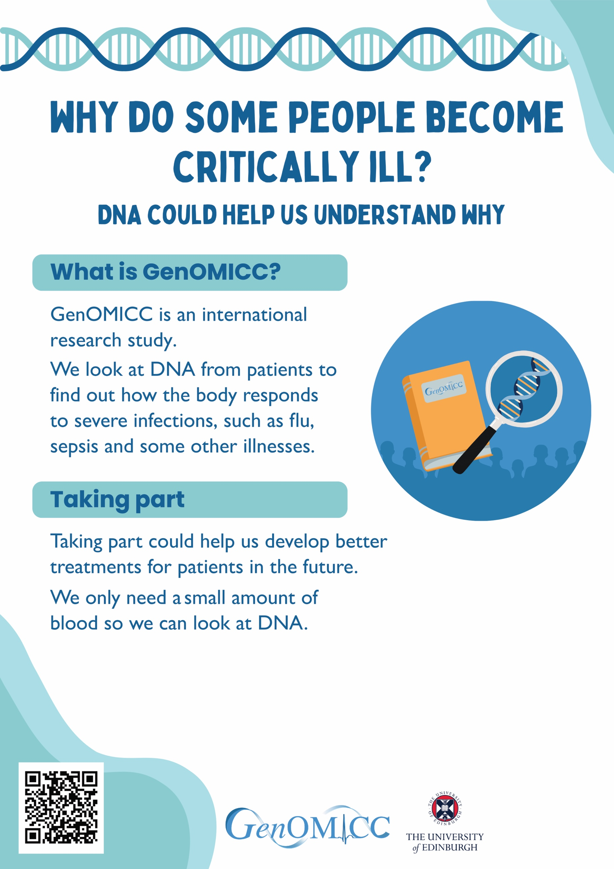
If you would like to know more, speak to one of the doctors or nurses looking after your loved one. OR
If you can take part, one of our research nurses will
speak to you about the study.
(Text can be adapted to include local contact names, and tailored to be relative or patient specific)

place hospital logo and/or delete text

