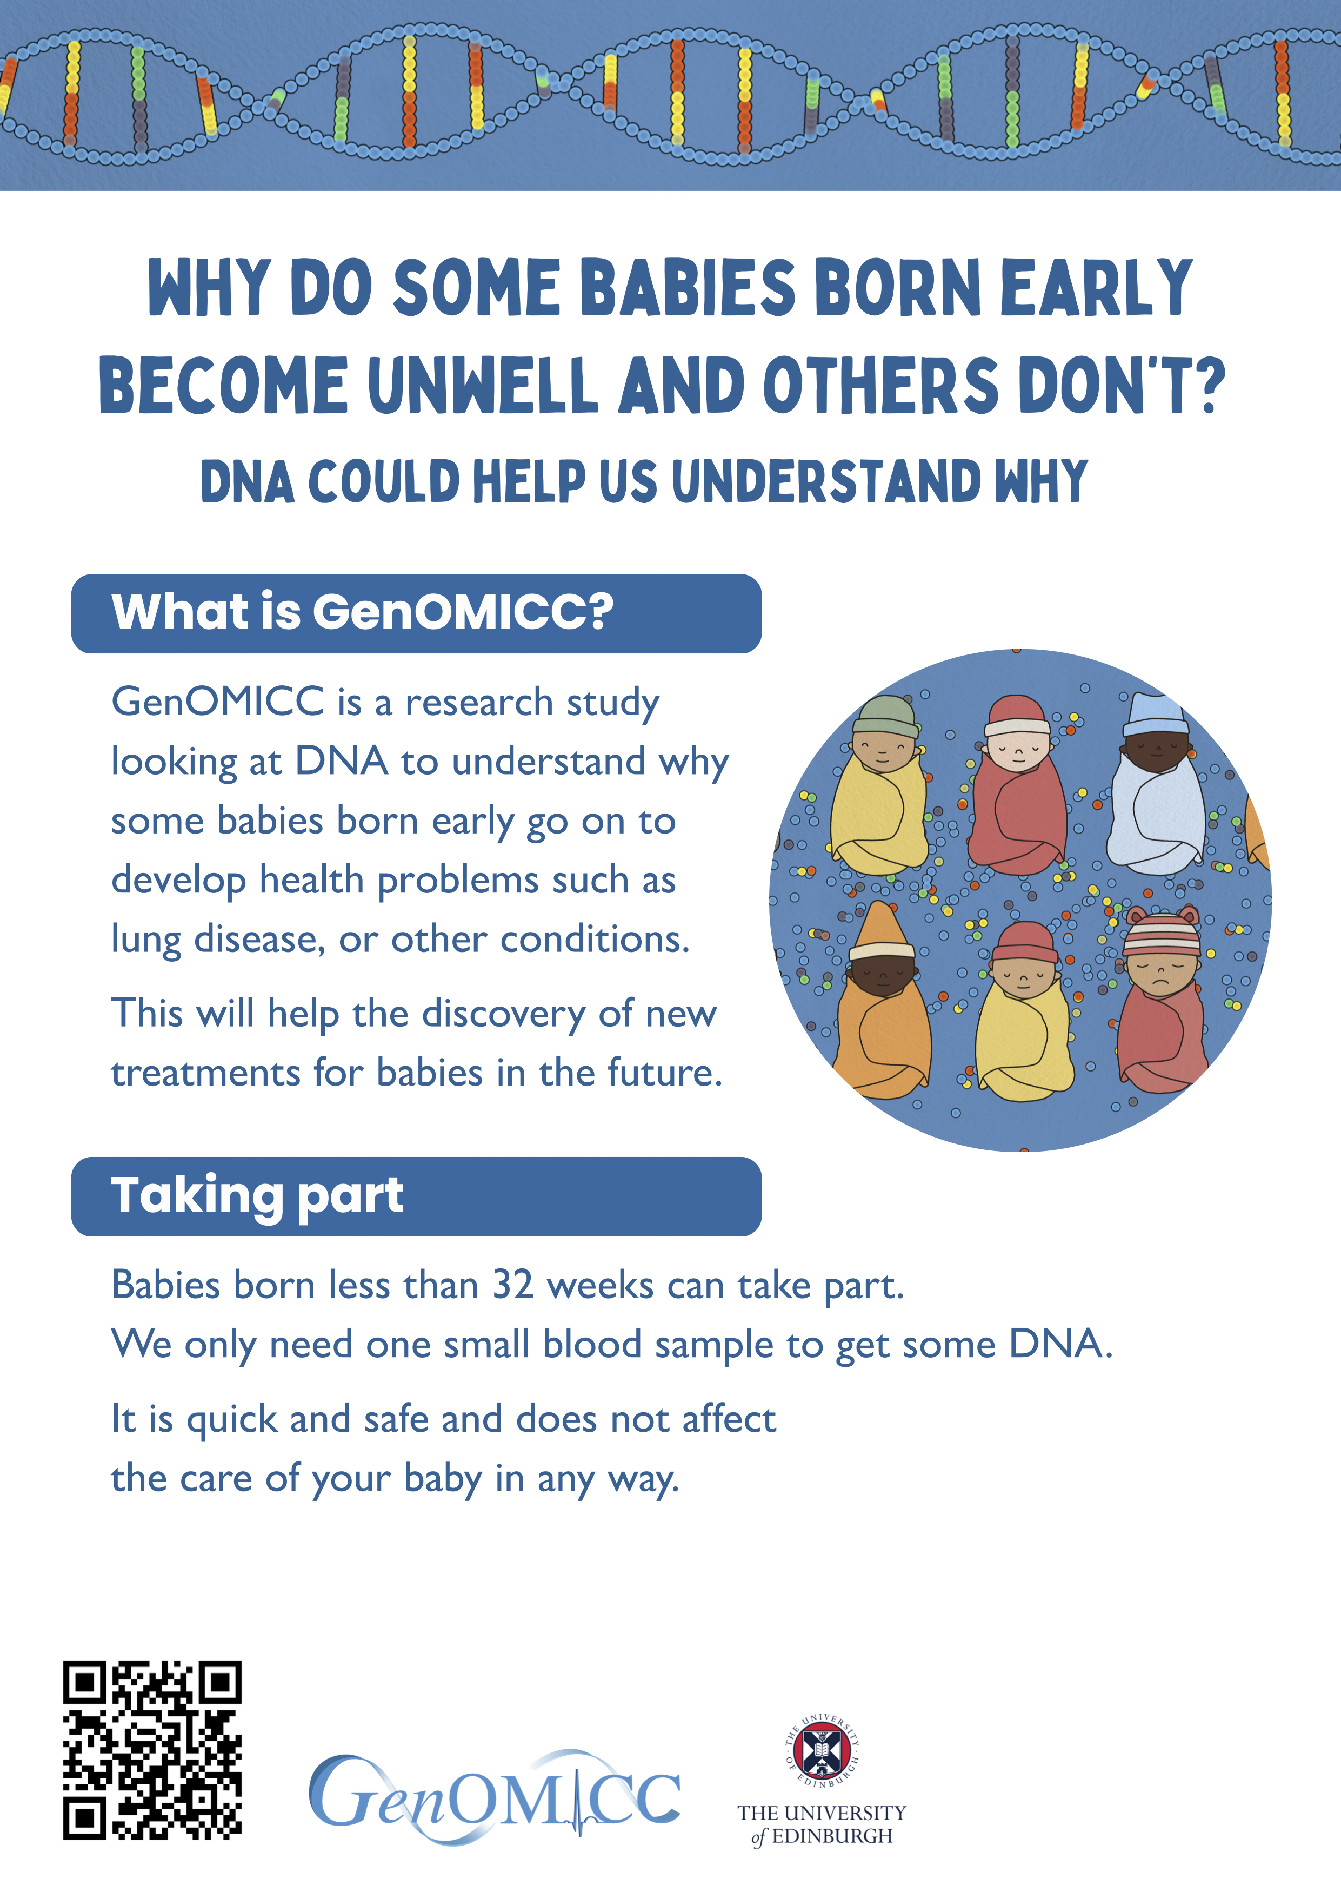
(Text can be personalised)
If you would like to know more, speak to one of the doctors or nurses looking after your baby.
place hospital logo and/or delete text

